荣耀时刻｜长园电力荣获广东省质量发展促进会科技进步三等奖，智能高压电缆附件技术再获行业荣光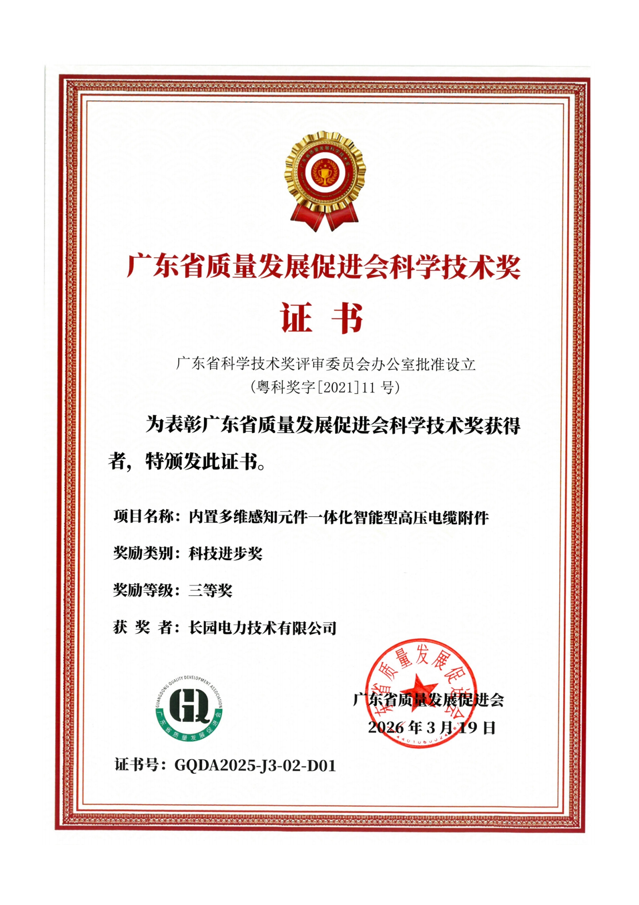
近日，2026年度“智联万物・质创共生”春茗会顺利召开。会议圆满举行2025年度广东省质量发展促进会科学技术奖授证仪式，长园电力凭借“内置多维感知元件一体化智能型高压电缆附件项目”荣获广东省质量发展促进会科技进步奖三等奖。此项荣誉是对公司在智能与高压电缆附件领域技术融合创新、质量提升与工程应用成效的权威肯定，彰显了长园电力深耕智能电网、以技术创新赋能电力装备高质量发展的核心实力。
作为专业的智能电网解决方案提供商和运营服务商，长园电力始终聚焦新型电力系统构建需求和技术发展前沿，加强自研技术策源地建设，强化原创性引领性科技攻关，筑牢科技创新根基和底座。本次获奖项目遵循国家电网智慧物联体系顶层设计，采用一体化创新设计，有效提升高压电缆附件自感知能力，精准实现运行状态实时监测和电缆智能运维，有力支撑高压电缆设备智能化升级，助力提升高压电缆系统的状态管控能力，优化电网运行效率的同时进一步降低运维风险，为电网安全稳定运行提供更优质的综合解决方案。
展望“十五五”，长园电力将以硬核实力铸就荣光，不断激励前进跨越。始终紧扣集团发展战略与整体布局，持续聚焦新型电力系统建设，不断强化一体化、智能化、模块化产品升级及技术创新，加快科技成果转化为可复用的工程与产业标准，真正提升全要素生产率，加速推动电网智能化发展，为能源强国建设与电力行业高质量发展贡献一份长园力量！

近日，2026年度“智联万物・质创共生”春茗会顺利召开。会议圆满举行2025年度广东省质量发展促进会科学技术奖授证仪式，长园电力凭借“内置多维感知元件一体化智能型高压电缆附件项目”荣获广东省质量发展促进会科技进步奖三等奖。此项荣誉是对公司在智能与高压电缆附件领域技术融合创新、质量提升与工程应用成效的权威肯定，彰显了长园电力深耕智能电网、以技术创新赋能电力装备高质量发展的核心实力。 | Recently, the 2026 Spring Symposium under the theme “Connecting All Things through Intelligence, Achieving Co-existence through Quality” was successfully held. During the conference, the certificate-awarding ceremony for the 2025 Science and Technology Award of the Guangdong Provincial Association for Quality Development was smoothly conducted. CYG Electric Co., Ltd. was honored with the Third Prize of the Science and Technology Progress Award from the Guangdong Provincial Association for Quality Development for its project titled “Integrated Intelligent High-Voltage Cable Accessories with Built-in Multidimensional Sensing Elements.” This award serves as an authoritative recognition of the company’s technological integration and innovation in the field of intelligent and high-voltage cable accessories, as well as its achievements in quality improvement and engineering application. It highlights CYG Electric’s core strength in deeply cultivating the smart grid sector and empowering the high-quality development of power equipment through technological innovation.
作为专业的智能电网解决方案提供商和运营服务商，长园电力始终聚焦新型电力系统构建需求和技术发展前沿，加强自研技术策源地建设，强化原创性引领性科技攻关，筑牢科技创新根基和底座。本次获奖项目遵循国家电网智慧物联体系顶层设计，采用一体化创新设计，有效提升高压电缆附件自感知能力，精准实现运行状态实时监测和电缆智能运维，有力支撑高压电缆设备智能化升级，助力提升高压电缆系统的状态管控能力，优化电网运行效率的同时进一步降低运维风险，为电网安全稳定运行提供更优质的综合解决方案。 | As a professional smart grid solution provider and operation service provider, CYG Electric Co.,Ltd. has always been focusing on the construction needs of new power systems and the frontiers of technological development. The Company strengthens the development of its proprietary technology innovation hubs, intensifies original and leading technological breakthroughs, and consolidates the foundation and cornerstone of technological innovation. The award-winning project follows the top-level design of the State Grid's smart IoT architecture and adopts an integrated innovative design, effectively enhancing the self-sensing capability of high-voltage cable accessories. It accurately enables real-time monitoring of operating conditions and intelligent cable operation and maintenance, strongly supports the intelligent upgrading of high-voltage cable equipment, and helps improve the condition monitoring and control capability of high-voltage cable systems. By optimizing the operational efficiency of the power grid while further reducing operation and maintenance risks, the project provides a more comprehensive solution for the safe and stable operation of the power grid.
展望“十五五”，长园电力将以硬核实力铸就荣光，不断激励前进跨越。始终紧扣集团发展战略与整体布局，持续聚焦新型电力系统建设，不断强化一体化、智能化、模块化产品升级及技术创新，加快科技成果转化为可复用的工程与产业标准，真正提升全要素生产率，加速推动电网智能化发展，为能源强国建设与电力行业高质量发展贡献一份长园力量！ | Looking ahead to the 15th Five-Year Plan period, CYG Electric Co.,Ltd. will forge glory with its solid core competencies and continuously drive progress and breakthroughs. The Company will remain closely aligned with the Group's development strategy and overall layout, continue to focus on the construction of new power systems, and further strengthen the upgrade and technological innovation of integrated, intelligent, and modular products. It will accelerate the transformation of scientific and technological achievements into reusable engineering and industrial standards, truly enhance total factor productivity, and accelerate the intelligent development of power grids. In doing so, CYG Electric will contribute its share of "CYG power" to the construction of a leading energy nation and the high-quality development of the power industry.

