协同攻坚 再攀高峰｜长园电力助力全国首套220千伏高压交流热塑性聚丙烯电缆系统研制成功
近日，由中国电力科学研究院牵头研制、长园电力作为核心协同单位参与的220千伏新型热塑性聚丙烯电缆系统，在珠海顺利通过全部型式试验。这是国内首套采用自主绝缘、屏蔽材料及自主电缆附件的该等级聚丙烯电缆系统，标志着我国高压热塑性环保电缆技术实现关键性突破。
Recently, the 220kV novel thermoplastic polypropylene cable system, led by China Electric Power Research Institute and co-developed with Changyuan Electric Power as a core partner, has successfully passed all type tests in Zhuhai. As China’s first 220kV polypropylene cable system adopting domestically developed insulation, shielding materials and cable accessories, the achievement marks a critical breakthrough in China’s high-voltage eco-friendly thermoplastic cable technology.
作为此次国家级科研攻关的重要参与方，长园电力与中国电科院、全球能源互联网欧洲研究院等单位紧密协同，成功攻克从110千伏到220千伏电压等级跨越所面临的核心技术难题。
As an important participant in this national key research project, Changyuan Electric Power has collaborated closely with China Electric Power Research Institute, Global Energy Interconnection Research Institute Europe and other entities to overcome core technical obstacles in the voltage class upgrade from 110 kV to 220 kV.
在项目攻坚阶段，长园电力充分利用自己在电缆附件领域的深厚技术积累与沉淀，配合项目牵头单位，完成220千伏聚丙烯电缆附件的开发，从设计、生产、安装和试验全流程匹配国产聚丙烯绝缘料电缆系统的要求，助力220千伏聚丙烯电缆及附件系统技术突破，实现核心技术自主可控，成功打破聚丙烯高压电缆及附件技术升级瓶颈。
During the critical development phase, leveraging its profound technical expertise in cable accessories, Changyuan Electric Power cooperated with the project lead to develop 220kV polypropylene cable accessories. The full-cycle processes including design, manufacturing, installation and testing were tailored to meet the requirements of domestically made polypropylene-insulated cable systems. The company facilitated technological breakthroughs of the 220kV polypropylene cable and accessory system, secured independent control over core technologies and successfully removed technical bottlenecks restricting the upgrade of high-voltage polypropylene cables and accessories.
下一步，长园电力将持续协同产业链伙伴，加速推动220千伏聚丙烯电缆工程落地，并着力攻关更高电压等级聚丙烯电缆附件技术。秉持“研发—转化—标准”全链条创新理念，长园电力将为我国高压电缆产业的绿色转型与自主化发展注入强劲动能，持续夯实高端电力装备的“长园力量”。
Going forward, Changyuan Electric Power will continue to cooperate with industrial chain partners to accelerate the practical application of 220kV polypropylene cable projects and focus on developing cable accessory technologies for higher voltage levels. Adhering to the full-chain innovation philosophy of "R&D-commercialization-standardization", it will fuel the green transformation and indigenous development of China’s high-voltage cable industry and consolidate Changyuan’s strengths in high-end power equipme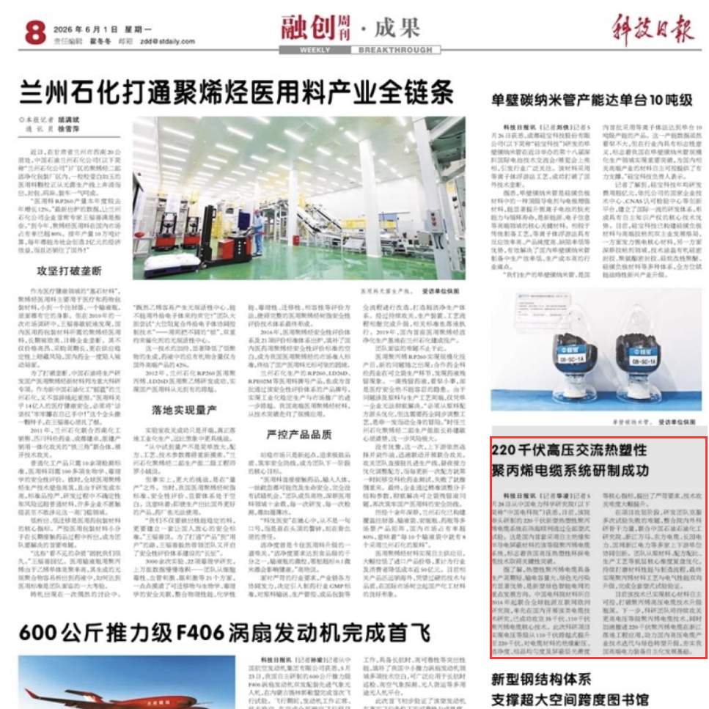nt.

